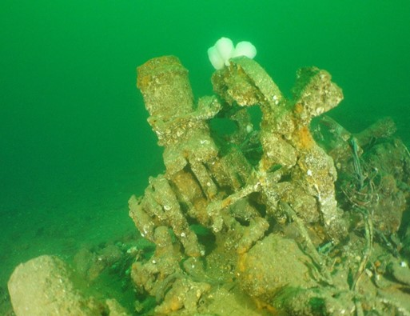
Photo 1: Bristol Pegasus radial engine (Engine 1; UASBC photo).

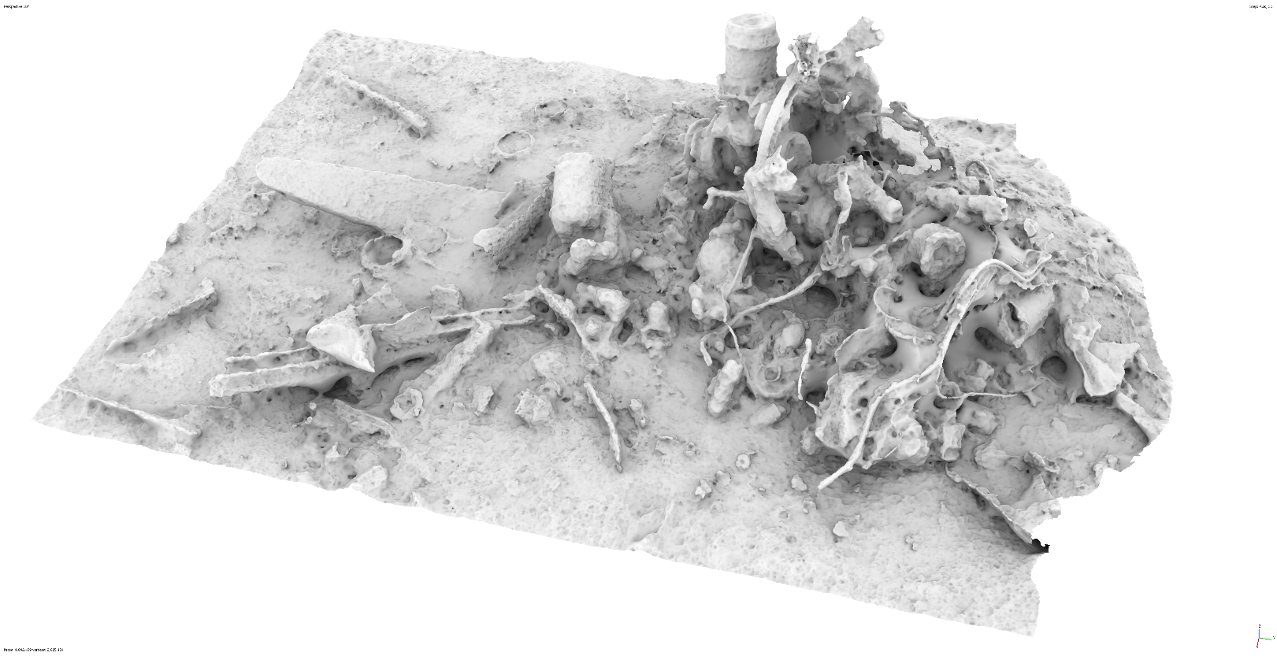
Photo 2: View south to rear of Engine 1 and debris field (from 3D model).

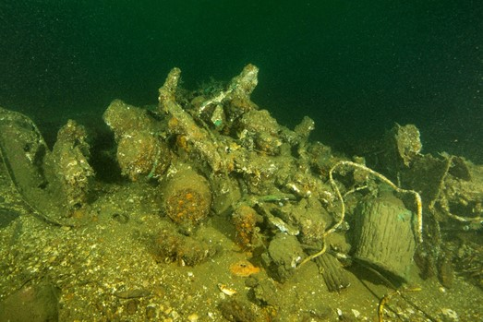
Photo 3: Bristol Pegasus radial engine (Engine 2; Lyle Berzins photo).

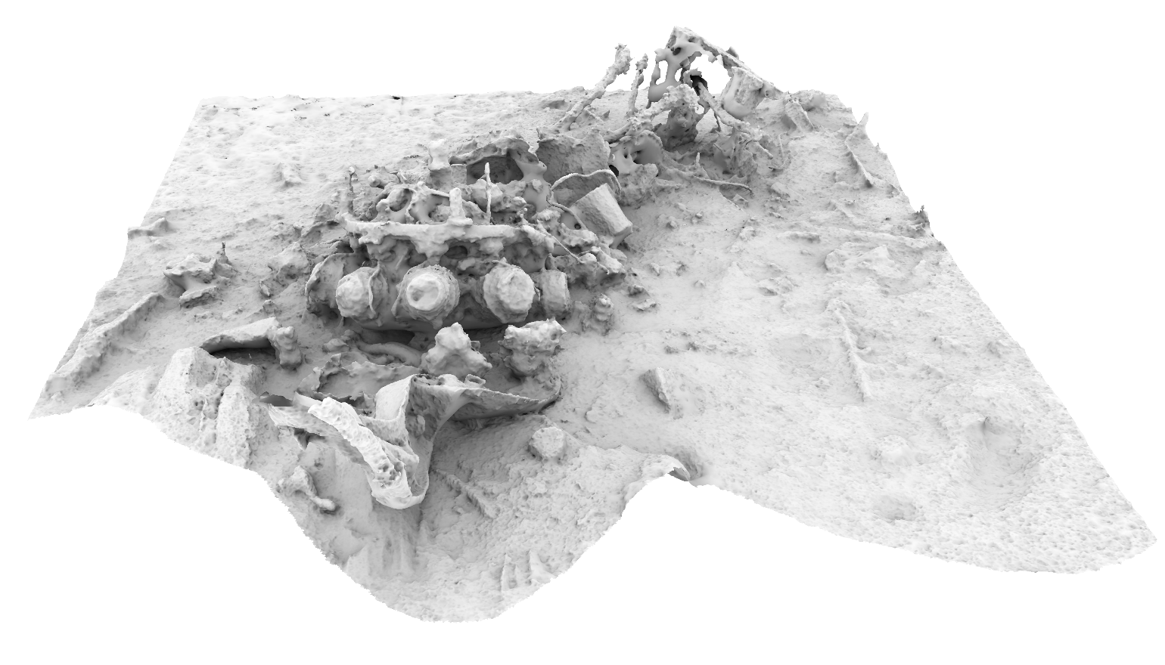
Photo 4: View southeast to Engine 2 and debris field (from 3D model).

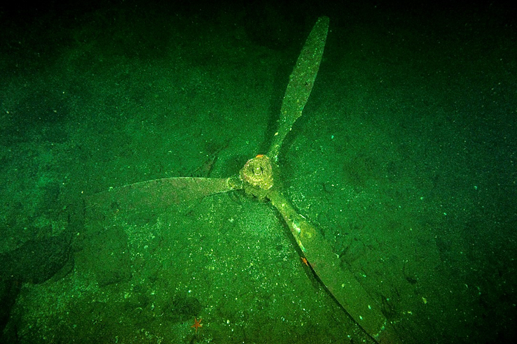
Photo 5: Propeller 2 (Lyle Berzins photo).

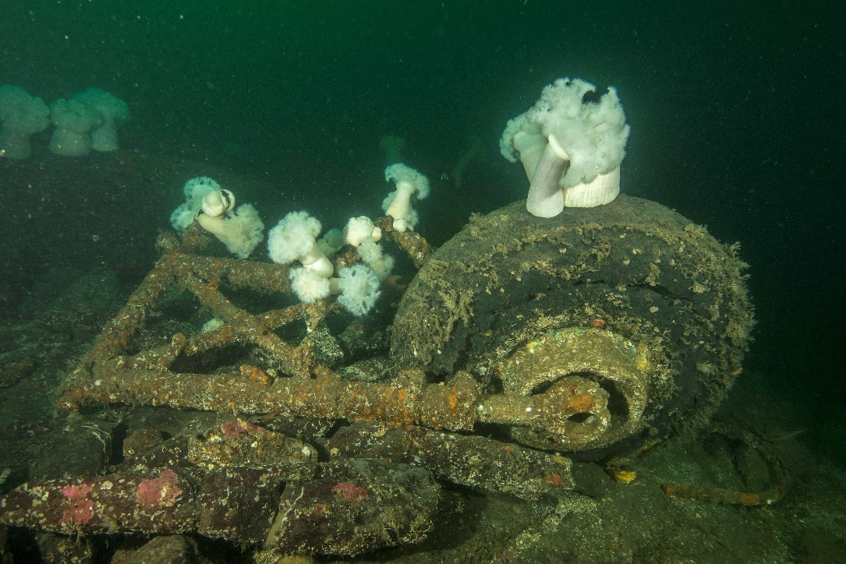
Photo 6: Landing gear (Lyle Berzins photo).

